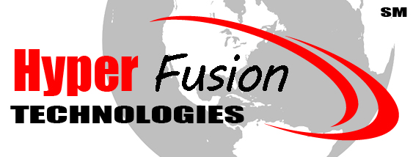
Hyper Fusion, LLC
3400 S Water Street
Burnet, TX 78611
www.hyperfusiontech.com
(512) 790-2250

Date: 2/2/2023
Re : Last Mile Grant Project – Texas

To Whom it may concern:

I am writing in support of Hyper Fusion, LLC being granted funds through both the Texas and Federally available Last Mile Grant programs.

As a rural internet subscriber, we would greatly benefit from any deployment of fiber optic and fixed point wireless infrastructure. Our initial goal is to obtain a reliable and stable internet package that runs at least 100 Mbps. As I am sure you maybe aware, the rural internet options throughout Texas is dismal at best.

While there are few choices to select from in our area, they are over priced and do not meet the national broadband speeds set by the FCC. Meanwhile, the big box wireless companies only care about the larger cities such as Austin, San Antonio, Dallas and Houston. High population areas such as these mean more money, which in the end is what those bigger companies are all about.

As a citizen of a rural community, we constantly are being left behind with technology infrastructure upgrades. Hyper Fusion seems to be the only provider specifically addressing our issues and needs, while providing competitive pricing.

We have ALREADY benefited greatly from Hyper Fusion's entry level service, but we need faster speeds and better bandwidth due to working from home, remote learning, home schooling, and other activities that are upload intensive. However, we still remain lacking in hardline fiber optic services, both to our location, as well as at least getting fiber to the wireless repeater tower that currently provides service to my local area.

Alot of the big tech folks moving to the Austin area are flooding to the Hill Country of Texas, specifically, the Greater Highland Lakes Texas Counties; Burnet County, Lampasas County, Llano county, Williamson County, Travis County, Blanco County, Hays County, and Comal County specifically. By granting Hyper Fusion funds to greatly expand their coverage of their highspeed products such as direct fiber they call Fusion Fiber as well as “Gigabit Over Wireless” service they now have available, but it is in very limited areas.

In Conclusion, we believe in helping Hyper Fusion, LLC as they continually put their community first and give back through local High-school Scholarship programs, growing the local economy, as well as bring jobs to our community.

Please Help us Fuse our Community by providing Last Mile Funding to Hyper Fusion, LLC and allowing my family and community to receive the internet speeds we need to connect to the future.

Sincerely,

(REPLACE THIS WITH YOUR NAME, AND THEN SIGN ABOVE)

